**Property Sales Analysis in Vanderburgh County, Indiana - A Comprehensive Study of Real Estate Trends in 2013**

This report presents an in-depth analysis of property sales data in Vanderburgh County, Indiana, focusing on the dynamic real estate trends observed during the year 2013. The analysis provides valuable insights into the local real estate market, encompassing property types, values, conditions, buyer demographics, and critical trends. Stakeholders can leverage these insights to make informed decisions and navigate the market effectively.

The residential sector emerged as the dominant force in the Vanderburgh County property sales market in 2013, accounting for the majority of transactions. The median sold price for residential properties was $80,000, indicating a stable and moderately appreciating market. Notably, a significant number of properties were sold with vacant possession, highlighting a strong buyer preference for move-in ready homes.

The report delves into the distribution of property conditions, revealing that a notable proportion of sold properties fell into the "Bad" category. This underscores the importance for property owners to invest in maintenance and improvement initiatives to enhance market appeal. The analysis also explores the correlation between property condition and sold prices, uncovering insights into buyer preferences and market dynamics.

In 2013, the average sold price for properties in Vanderburgh County was $129.71K, serving as a benchmark for pricing trends and investment assessments.

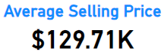

Geographically, the city of Evansville emerged as the epicenter of property ownership in Vanderburgh County, with a significant concentration of owners residing in this area. This localized market concentration suggests the need for targeted marketing and tailored strategies to capitalize on the unique dynamics of the Evansville market.

Overall, this comprehensive analysis of property sales data in Vanderburgh County during 2013 equips stakeholders with valuable insights to navigate the market effectively. Whether you are a seller seeking to maximize property value, a buyer looking for the ideal home, or an investor evaluating strategic opportunities, this report provides a comprehensive understanding of the Vanderburgh County real estate landscape and supports informed decision-making.

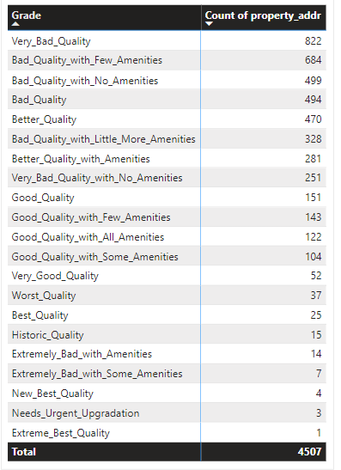 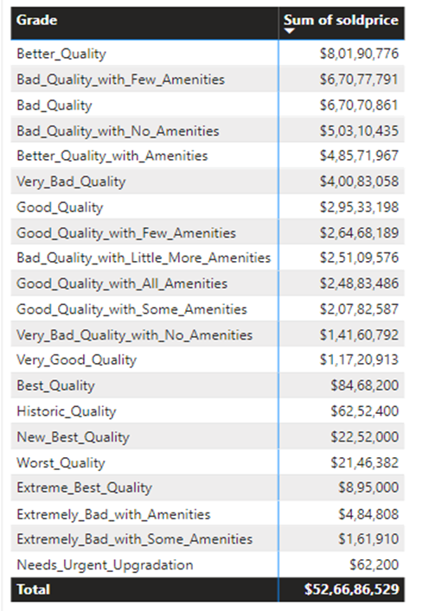

Overall, this report provides valuable insights into the property sales market in Vanderburgh County, Indiana, during the year 2013. The findings presented here aim to support various stakeholders, including real estate professionals, investors, and policymakers, in making informed decisions and gaining a deeper understanding of the local real estate landscape.

Please note that the data used for this analysis is based on public records and may have certain limitations. The analysis should be considered as a reference and not as financial or investment advice.

**Geographic Distribution**

The geographic distribution of property sales in Vanderburgh County reflects a concentration of sales in urban areas, particularly in the city of Evansville. With 4,581 homes bought, Evansville emerges as the place with the highest number of property owners. This indicates a strong demand for real estate in the city, likely driven by various factors such as economic opportunities, amenities, and community attractions.

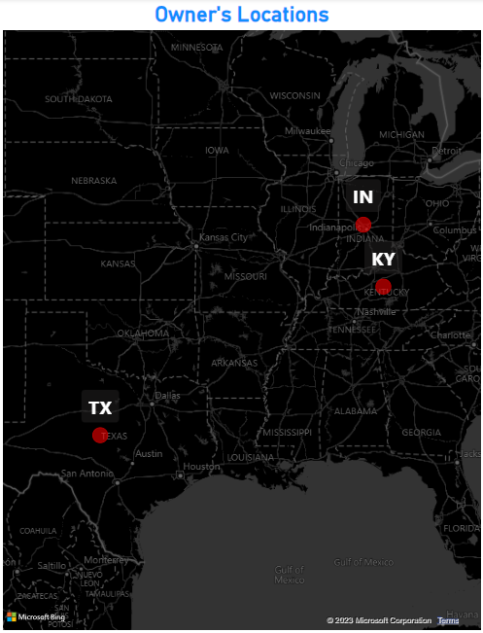

Top 3 locations which bought the maximum number of Homes

**Condition vs. Sold Price d Analysis**

The analysis of property conditions, sold prices, and the corresponding number of homes sold in Vanderburgh County yields the following key observations:

1. "Available" properties have the highest total sold price, amounting to $453,370,320, and the highest number of homes sold, with 3,709 properties. This indicates that properties in good condition and readily available to buyers are highly sought after, leading to higher prices and a larger volume of sales. The high demand for these properties can be attributed to factors such as location, amenities, and overall quality.
2. Properties in "fair_condition" have a total selling price of $57,791,365.5, with 533 homes sold. Although the total sold price is lower compared to "Available" properties, properties in fair condition still attract a significant number of buyers. This suggests that buyers are willing to consider properties that may require some repairs or improvements at a relatively lower price point.
3. "good_condition" properties have a total sold price of $11,847,833, with 83 homes sold. These properties are generally well-maintained and meet the expectations of buyers in terms of quality and condition. Although the total selling price and the number of homes sold are lower compared to properties in "Available" and "fair_condition," they still represent a significant portion of the real estate market.
4. Properties in "poor condition" and "Vacant_Possession" have lower total sold prices, standing at $5,963,130 and $654,449, respectively. The number of homes sold for properties in "poor condition" is 110, while for "Vacant_Possession" properties, it is 86. These properties may require significant repairs or renovations, leading to a lower market value and a smaller number of sales.
5. "very_good_condition" and "extremely_good_condition" properties have total sold prices of $835,000 and $560,741, respectively. The number of homes sold for both conditions is relatively low, with 3 properties each. These properties command higher prices due to their exceptional condition and quality, but the limited supply results in a smaller number of sales.

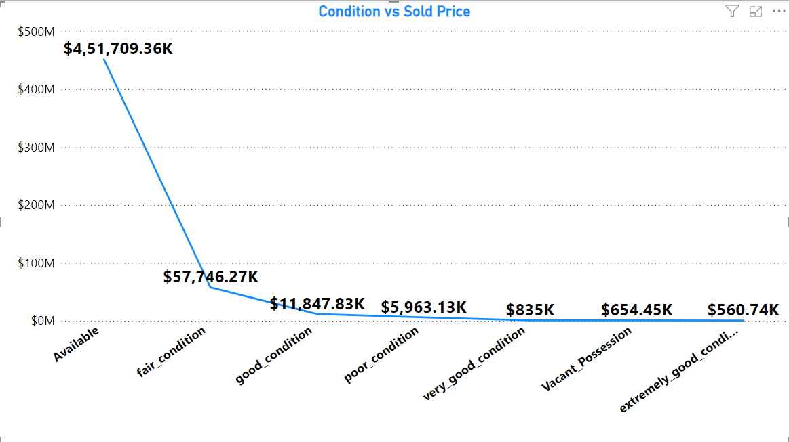

The analysis emphasizes the relationship between property condition, sold prices, and the number of homes sold. Properties in good condition and readily available to buyers tend to have higher prices and a larger volume of sales, reflecting the market's preference for quality and convenience. On the other hand, properties in poor condition or requiring repairs have lower prices and a smaller number of sales. Understanding this relationship is crucial for buyers, sellers, and real estate professionals in making informed decisions based on their specific needs and objectives.

The analysis of property condition, sold prices, and the number of homes sold in Vanderburgh County provides valuable insights into the real estate market dynamics. The findings highlight the significance of property conditions in influencing both the prices and the number of homes sold.

Properties in "Available" condition stand out with the highest total selling price and the highest number of homes sold, indicating strong demand from buyers. These properties are attractive due to their good condition and immediate availability. However, properties in other conditions, such as "fair_condition," "good_condition," "poor_condition," and "Vacant_Possession," also contribute to the overall real estate market in Vanderburgh County, catering to buyers with diverse preferences and budgetary considerations.

Properties in "very_good_condition" and "extremely_good_condition" command higher prices but have a smaller number of sales, primarily due to their limited availability. Buyers seeking properties in exceptional condition and quality are willing to pay a premium, even if the inventory is relatively scarce.

These findings provide valuable information for buyers, sellers, and real estate professionals to make informed decisions. Buyers can consider the relationship between property condition, sold prices, and the number of homes sold when evaluating their options and aligning them with their preferences and budget. Sellers and real estate professionals can use this knowledge to strategically price and market properties, taking into account the market demand for different property conditions.

Overall, understanding the interplay between property condition, sold prices, and the number of homes sold is crucial for navigating the real estate market in Vanderburgh County, facilitating informed decision-making, and maximizing opportunities for both buyers and sellers.

**Top 5 Property Owners in Vanderburgh County, IN**

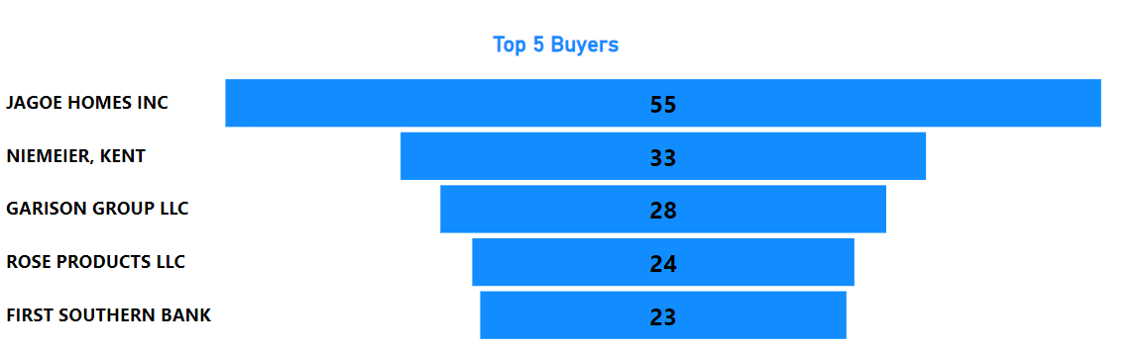

Based on our analysis of property ownership, we have identified the top 5 owners who have made a significant impact on the real estate market in Vanderburgh County, IN. These owners have demonstrated their strong presence by acquiring a considerable number of properties.

Among the top owners, **JAGOE HOMES INC** stands out as the largest property owner with a total of 49 properties. Their extensive portfolio showcases their expertise and success in the real estate industry.

Following closely behind is **NIEMEIER, KENT**, who owns 32 properties. Their significant investment in the local housing market has contributed to the growth and development of the area.

**GARISON GROUP LLC** holds ownership of 27 properties, highlighting their active involvement in property acquisition and management. Their presence adds diversity to the real estate landscape in Vanderburgh County.

**ROSE PRODUCTS LLC** owns 24 properties, indicating their commitment to the local housing market. Their contributions have helped shape the real estate sector in the county.

Finally, **FIRST SOUTHERN BANK** has a notable presence with 23 properties. As a financial institution, its involvement in property ownership demonstrates its strategic approach to diversifying its assets.

These top 5 property owners play a vital role in shaping the real estate market in Vanderburgh County. Their investments, expertise, and strategic decisions impact property values, market trends, and the overall growth of the housing sector.

**Real Estate Market Analysis: Monthly Total Sold Prices**

The following analysis provides a comprehensive overview of the real estate market in Vanderburgh County, IN, focusing on the monthly total sold prices from January 2013 to March 2014. This report aims to unveil key insights and trends derived from the data, enabling stakeholders to make informed decisions. The analysis explores the variations in total sold prices, identifies notable months, and highlights the implications for buyers, sellers, and investors.

**Key Findings:**

**Monthly Total Sold Prices:**

* The total sold prices exhibited significant variations throughout the analyzed period, reflecting the dynamic nature of the real estate market.
* January 2013 marked the beginning of the period with a total sold price of $35,472,157, indicating substantial market activity.
* March 2014 witnessed a significant increase in total sold prices, reaching $142,500.

**Fluctuations and Trends:**

* The analysis reveals fluctuations in total sold prices, signifying changing market dynamics and demand-supply patterns.
* Months such as February 2013, June 2013, and October 2013 recorded higher total sold prices, suggesting increased market activity and potential opportunities for sellers.
* Conversely, February 2014 and October 2013 experienced relatively lower total sold prices, indicating a potential buyer's market during those periods.

**Geographic Distribution:**

The majority of property sales were concentrated in urban areas, with the city of Evansville witnessing the highest number of home purchases.

Suburban and rural areas also witnessed a significant number of property sales, indicating a diverse real estate market in Vanderburgh County.

Based on the findings of this analysis, the following recommendations can be made:

**Market Analysis:**

* Stakeholders should continue monitoring the monthly total sold prices to stay informed about market trends and fluctuations.
* Analyzing the variations in total sold prices can provide insights into the overall health and performance of the real estate market in Vanderburgh County.

**Strategic Planning:**

* Buyers and sellers should consider the fluctuating total sold prices when planning their real estate transactions.
* Understanding the months with historically higher or lower total sold prices can help stakeholders strategically time their buying or selling decisions.

The analysis of monthly total sold prices offers valuable insights into the real estate market in Vanderburgh County. The variations and trends identified in this report highlight the dynamic nature of the market and provide stakeholders with valuable information for decision-making. By monitoring the market closely and considering strategic planning, stakeholders can navigate the real estate landscape effectively. The geographic distribution of property sales also emphasizes the importance of considering both urban and suburban areas when analyzing the market. With these insights, stakeholders can make informed decisions and capitalize on opportunities within the Vanderburgh County real estate market.

Note: Please refer to the attached image for a visual representation of the monthly total sold prices during the analyzed period.

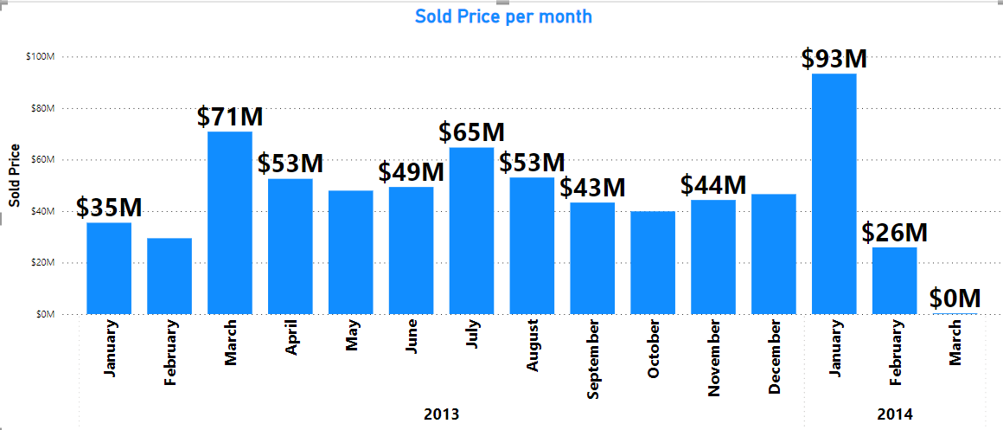

This comprehensive report presents a detailed analysis of the monthly total sold prices, allowing stakeholders to gain a deeper understanding of the real estate market in Vanderburgh County. The insights provided in this report, along with the visual representation, empower stakeholders to make strategic decisions and navigate the market effectively.